**APPENDICES**

**DATA GATHERING INSTRUMENTS**

**CLIENT FORMS & REPORTS**

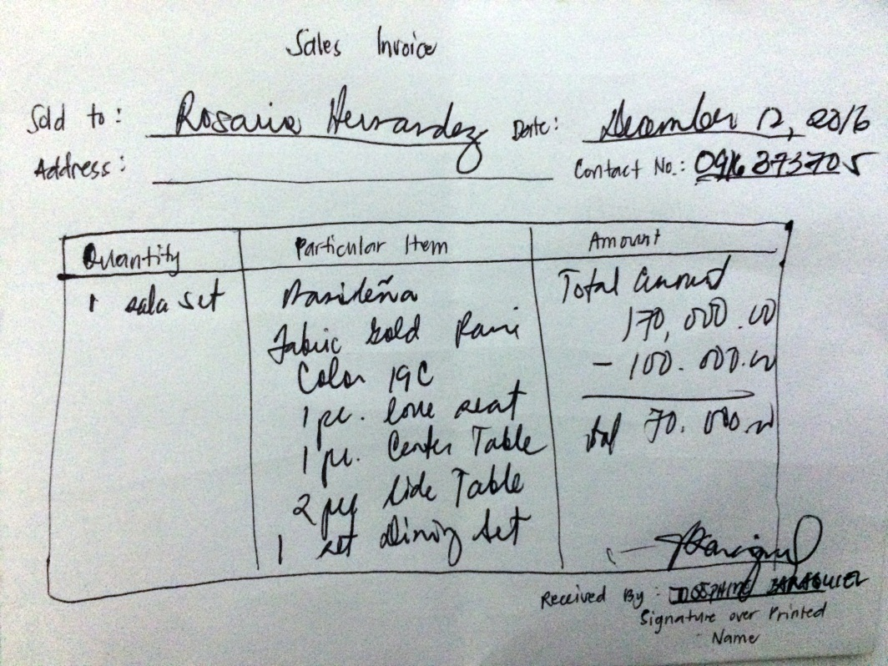

***Sales Invoice Format***

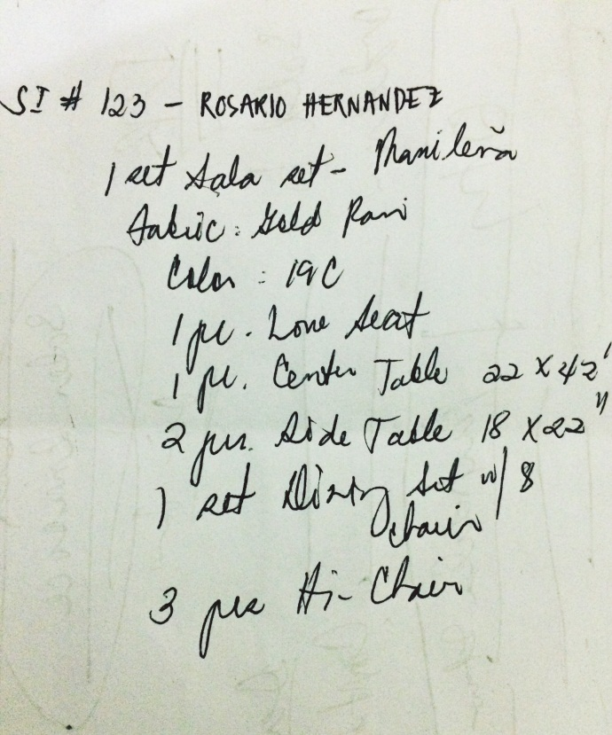

***Job Order Format***

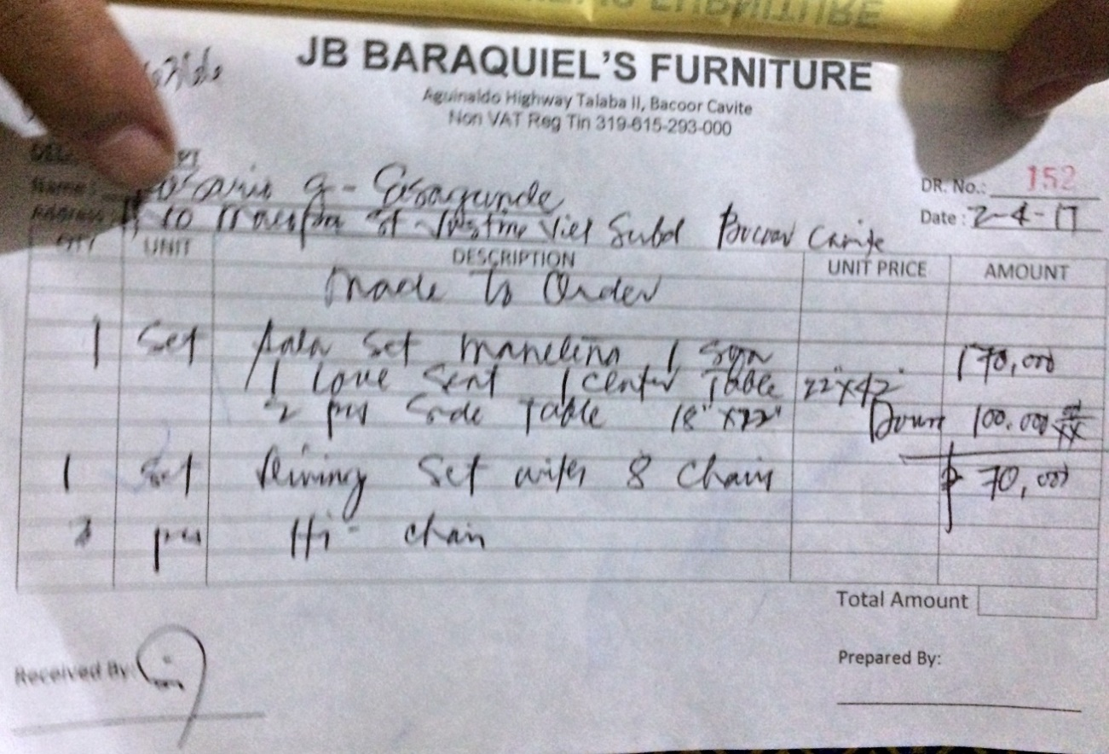

***Delivery Receipt***

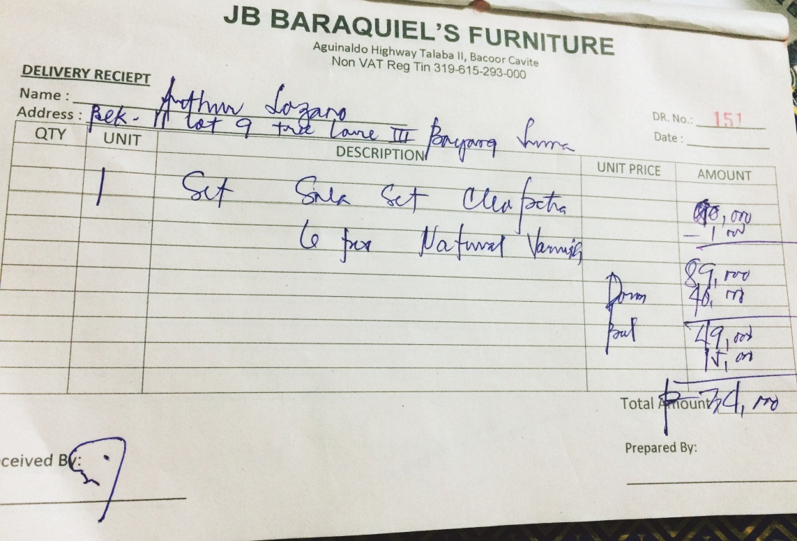

***Delivery Receipt***

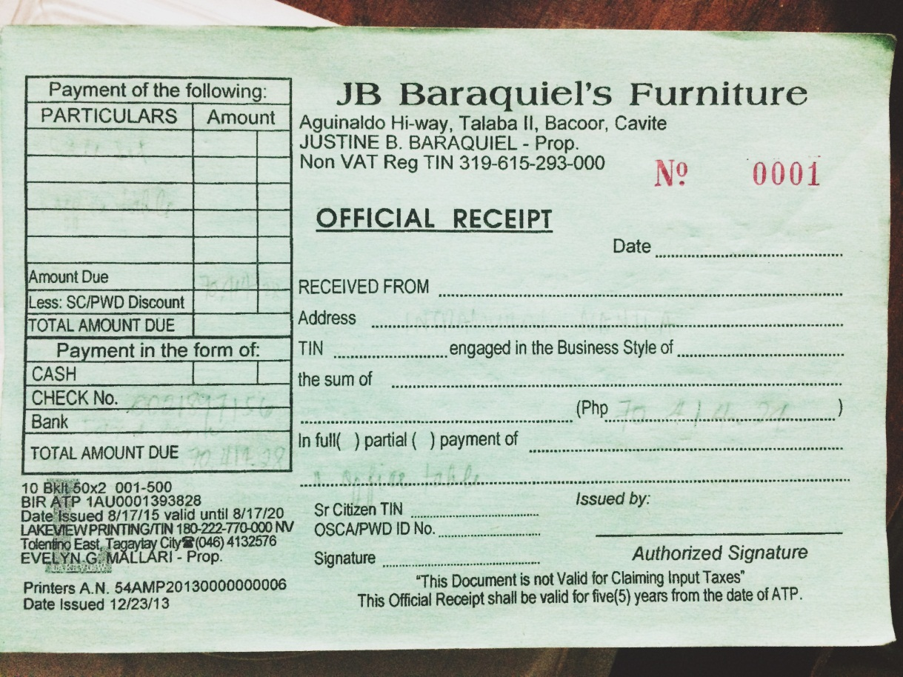

***Official Receipt***

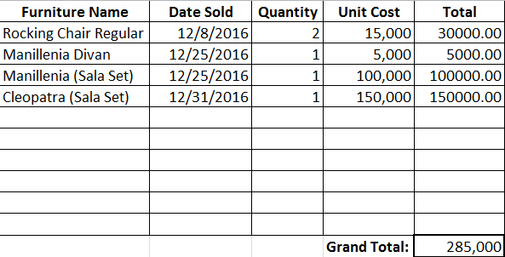

***Sales Report Format***

**LETTER OF REQUEST FOR THE STUDY**

**SCREEN LAYOUT (SCREENSHOTS)**

**SOURCE CODE**

**TEST SCRIPT**

|  |  |  |  |  |  |
| --- | --- | --- | --- | --- | --- |
| TEST CASE NAME | DESCRIPTION | EXPECTED RESULT | ACTUAL RESULT | STATUS | COMMENT |
| 1. Validate User Authentication | Input alphanumeric characters | Accept alphanumeric characters | Alphanumeric characters accepted | Passed |  |
| Input symbols | Does not accept symbols | Does not accept symbols | Passed |  |
| Input characters in different cases | Does not accept field if username already exist | Existing username is not accepted | Passed |  |
| Input not existing account | Error message is displayed | Error message is displayed | Passed |  |
|  | No access to the home page | No access to the home page | Passed |  |
| Input wrong password | Error message is displayed | Error message is displayed | Passed |  |
|  | User cannot access the system | User cannot access the system | Passed |  |
| Click "Login" button | Admin page is displayed | Admin page is displayed | Passed |  |
|  | User can access the system | User can access everything in the system | Passed |  |
| 2. Dashboard | Access Dashboard page | Initial data pf the system is displayed | Initial data pf the system is displayed | Passed |  |
|  | Current time and date is displayed | Current time and date is displayed | Passed |  |
|  | Logged in user's name is displayed | Logged in user's name is displayed | Passed |  |
| Click "Payment Notification" tab | Displays list of latest orders' payment information | Displays orders' payment information | Passed |  |
| Click "Customers" tab | Displays customers' information | Displays customers' information | Passed |  |
| Click "Create Newsletter" | Modal with text area must appear | Modal with text area appeared | Passed |  |
|  | Allows admin to send news letter to the customer | Allows admin to send news letter to the customer | Passed |  |
| Click "Send" button | Sends the news letter to the customers | Sends the news letter to the customers | Passed |  |
| Leave the text area empty | Error message is displayed | Error message is displayed | Passed |  |
| Click "Order Request" tab | Displays list of order requests from the website | Displays list of order requests from the website | Passed |  |
|  | Admin is allowed to view, accept and reject an order request | Admin is allowed to view, accept and reject an order request | Passed |  |
| Click "View" button | Displays order information of the order request | Displays order information of the order request | Passed |  |
| Click "Accept" button | Accepts order request | Accepts order request | Passed |  |
| Click "Reject" button | Decline the order request | Decline the order request | Passed |  |
|  | An email is sent to the customer | An email is sent to the customer | Passed |  |
| Click "Customization Request" tab | Display lists of customization requests from the website | Display lists of customization requests from the website | Passed |  |
| Click "View Details" button | Customization details is displayed | Customization details is displayed | Passed |  |
| Click "Balances" tab | Display lists of order balances | Display lists of order balances | Passed |  |
|  | User is allowed to bill the specific order | User is allowed to bill the specific order | Passed |  |
| Click "View" button | Displays details of the balance | Displays details of the balance | Passed |  |
| Click "Payment" button | Modify payment details of the order | Modify payment details of the order | Passed |  |
| Click "Bill" button | Prints Invoice of the order | Prints Invoice of the order | Passed |  |
| Click "Add Penalty" button | Adds order penalty to the specific order | Adds order penalty to the specific order | Passed |  |
|  | Allows user to view payment history of the order | Allows user to view payment history of the order | Passed |  |
| Click "Order Production" tab | Displays production information of ongoing order | Displays production information of ongoing order | Passed |  |
|  | User is allowed to view details of the order | User is allowed to view details of the order | Passed |  |
|  | User can start a production of a specific order | User can start a production of a specific order | Passed |  |
| Click "Start Production" button | User can view an order information | User can view an order information | Passed |  |
|  | Production will change to ongoing status | Production will change to ongoing status | Passed |  |
| Click "Materials Monitoring" tab | Displays list of materials and its information | Displays list of materials and its information | Passed |  |
| 3. Maintenance |  |  |  |  |  |
| Raw Materials | Click "Raw Materials" tab | Sub maintenance under raw materials are displayed | Sub maintenance under raw materials are displayed | Passed |  |
|  | Click "Supplier" | List of suppliers and its information is displayed | List of suppliers and its information is displayed | Passed |  |
| Click "New" button | Displays modal of fields to be fill up | Displays modal of fields to be fill up | Passed |  |
| Input symbols | Does not accept symbols | Does not accept symbols | Passed |  |
|  | Displays error message | Displays error message | Passed |  |
| Input alphanumeric characters | Accept alphanumeric characters | Alphanumeric characters accepted | Passed |  |
| Input characters in different cases | Does not accept field if it already exist | Existing field is not accepted | Passed |  |
|  | Displays error message | Displays error message | Passed |  |
| Leave required fields empty | Displays error message | Displays error message | Passed |  |
|  | Save button is disabled | Save button is disabled | Passed |  |
|  | Fields filled up are not saved | Fields filled up are not saved | Passed |  |
| Click "Save" button | Fields filled up are saved | Fields filled up are saved | Passed |  |
| Click "Cancel" button | Modal closes and supplier page is displayed | Modal closes and supplier page is displayed | Passed |  |
| Click "Update" button | Enable to update fields of a specific supplier | Enable to update fields of a specific supplier | Passed |  |
|  | Does not accept symbols | Does not accept symbols | Passed |  |
|  | Accept alphanumeric characters | Alphanumeric characters accepted | Passed |  |
|  | Does not accept field if it already exist | Existing field is not accepted | Passed |  |
| Click "Deactivate" button | Confirmation message is displayed | Confirmation message is displayed | Passed |  |
|  | Deactivates a specific supplier | Deactivates a specific supplier | Passed |  |
| Click "Unit of Measurement" | List of Unit of Measurement and its information is displayed | List of Unit of Measurement and its information is displayed | Passed |  |
| Click "New" button | Displays modal of fields to be fill up | Displays modal of fields to be fill up | Passed |  |
| Input symbols | Does not accept symbols | Does not accept symbols | Passed |  |
|  | Displays error message | Displays error message | Passed |  |
| Input alphanumeric characters | Accept alphanumeric characters | Alphanumeric characters accepted | Passed |  |
| Input characters in different cases | Does not accept field if it already exist | Existing field is not accepted | Passed |  |
|  | Displays error message | Displays error message | Passed |  |
| Leave required fields empty | Displays error message | Displays error message | Passed |  |
|  | Save button is disabled | Save button is disabled | Passed |  |
|  | Fields filled up are not saved | Fields filled up are not saved | Passed |  |
| Click "Save" button | Fields filled up are saved | Fields filled up are saved | Passed |  |
| Click "Cancel" button | Modal closes and Unit of Measurement page is displayed | Modal closes and Unit of Measurement page is displayed | Passed |  |
| Click "Update" button | Enable to update fields of a specific Unit of Measurement | Enable to update fields of a specific Unit of Measurement | Passed |  |
|  | Does not accept symbols | Does not accept symbols | Passed |  |
|  | Accept alphanumeric characters | Alphanumeric characters accepted | Passed |  |
|  | Does not accept field if it already exist | Existing field is not accepted | Passed |  |
| Click "Deactivate" button | Confirmation message is displayed | Confirmation message is displayed | Passed |  |
|  | Deactivates a specific Unit of Measurement | Deactivates a specific Unit of Measurement | Passed |  |
| Click "Material Attributes" | List of material attributes and its information is displayed | List of material attributes and its information is displayed | Passed |  |
| Click "New" button | Displays modal of fields to be fill up | Displays modal of fields to be fill up | Passed |  |
| Input symbols | Does not accept symbols | Does not accept symbols | Passed |  |
|  | Displays error message | Displays error message | Passed |  |
| Input alphanumeric characters | Accept alphanumeric characters | Alphanumeric characters accepted | Passed |  |
| Input characters in different cases | Does not accept field if it already exist | Existing field is not accepted | Passed |  |
|  | Displays error message | Displays error message | Passed |  |
| Leave required fields empty | Displays error message | Displays error message | Passed |  |
|  | Save button is disabled | Save button is disabled | Passed |  |
|  | Fields filled up are not saved | Fields filled up are not saved | Passed |  |
| Click "Save" button | Fields filled up are saved | Fields filled up are saved | Passed |  |
| Click "Cancel" button | Modal closes and material attributes page is displayed | Modal closes and material attributes page is displayed | Passed |  |
| Click "Update" button | Enable to update fields of a specific material attributes | Enable to update fields of a specific material attributes | Passed |  |
|  | Does not accept symbols | Does not accept symbols | Passed |  |
|  | Accept alphanumeric characters | Alphanumeric characters accepted | Passed |  |
|  | Does not accept field if it already exist | Existing field is not accepted | Passed |  |
| Click "Deactivate" button | Confirmation message is displayed | Confirmation message is displayed | Passed |  |
|  | Deactivates a specific material attributes | Deactivates a specific material attributes | Passed |  |
| Click "Material Type" | List of Material Type and its information is displayed | List of Material Type and its information is displayed | Passed |  |
| Click "New" button | Displays modal of fields to be fill up | Displays modal of fields to be fill up | Passed |  |
| Input symbols | Does not accept symbols | Does not accept symbols | Passed |  |
|  | Displays error message | Displays error message | Passed |  |
| Input alphanumeric characters | Accept alphanumeric characters | Alphanumeric characters accepted | Passed |  |
| Input characters in different cases | Does not accept field if it already exist | Existing field is not accepted | Passed |  |
|  | Displays error message | Displays error message | Passed |  |
| Leave required fields empty | Displays error message | Displays error message | Passed |  |
|  | Save button is disabled | Save button is disabled | Passed |  |
|  | Fields filled up are not saved | Fields filled up are not saved | Passed |  |
| Click "Save" button | Fields filled up are saved | Fields filled up are saved | Passed |  |
| Click "Cancel" button | Modal closes and Material Type page is displayed | Modal closes and Material Type page is displayed | Passed |  |
| Click "Update" button | Enable to update fields of a specific Material Type | Enable to update fields of a specific Material Type | Passed |  |
|  | Does not accept symbols | Does not accept symbols | Passed |  |
|  | Accept alphanumeric characters | Alphanumeric characters accepted | Passed |  |
|  | Does not accept field if it already exist | Existing field is not accepted | Passed |  |
| Click "Deactivate" button | Confirmation message is displayed | Confirmation message is displayed | Passed |  |
|  | Deactivates a specific Material Type | Deactivates a specificMaterial Type | Passed |  |
| Click "Materials" | List of Materials and its information is displayed | List of Materials and its information is displayed | Passed |  |
| Click "New" button | Displays modal of fields to be fill up | Displays modal of fields to be fill up | Passed |  |
| Input symbols | Does not accept symbols | Does not accept symbols | Passed |  |
|  | Displays error message | Displays error message | Passed |  |
| Input alphanumeric characters | Accept alphanumeric characters | Alphanumeric characters accepted | Passed |  |
| Input characters in different cases | Does not accept field if it already exist | Existing field is not accepted | Passed |  |
|  | Displays error message | Displays error message | Passed |  |
| Leave required fields empty | Displays error message | Displays error message | Passed |  |
|  | Save button is disabled | Save button is disabled | Passed |  |
|  | Fields filled up are not saved | Fields filled up are not saved | Passed |  |
| Click "Save" button | Fields filled up are saved | Fields filled up are saved | Passed |  |
| Click "Cancel" button | Modal closes and Materials page is displayed | Modal closes and Materials page is displayed | Passed |  |
| Click "Update" button | Enable to update fields of a specific Materials | Enable to update fields of a specificMaterials | Passed |  |
|  | Does not accept symbols | Does not accept symbols | Passed |  |
|  | Accept alphanumeric characters | Alphanumeric characters accepted | Passed |  |
|  | Does not accept field if it already exist | Existing field is not accepted | Passed |  |
| Click "Deactivate" button | Confirmation message is displayed | Confirmation message is displayed | Passed |  |
|  | Deactivates a specific Materials | Deactivates a specific Materials | Passed |  |
| Click "Material Variants" | List of material Variants and its information is displayed | List of material Variants and its information is displayed | Passed |  |
| Click "New" button | Displays modal of fields to be fill up | Displays modal of fields to be fill up | Passed |  |
| Input symbols | Does not accept symbols | Does not accept symbols | Passed |  |
|  | Displays error message | Displays error message | Passed |  |
| Input alphanumeric characters | Accept alphanumeric characters | Alphanumeric characters accepted | Passed |  |
| Input characters in different cases | Does not accept field if it already exist | Existing field is not accepted | Passed |  |
|  | Displays error message | Displays error message | Passed |  |
| Leave required fields empty | Displays error message | Displays error message | Passed |  |
|  | Save button is disabled | Save button is disabled | Passed |  |
|  | Fields filled up are not saved | Fields filled up are not saved | Passed |  |
| Click "Save" button | Fields filled up are saved | Fields filled up are saved | Passed |  |
| Click "Cancel" button | Modal closes and material Variants page is displayed | Modal closes and material Variants page is displayed | Passed |  |
| Click "Update" button | Enable to update fields of a specific material Variants | Enable to update fields of a specific material Variants | Passed |  |
|  | Does not accept symbols | Does not accept symbols | Passed |  |
|  | Accept alphanumeric characters | Alphanumeric characters accepted | Passed |  |
|  | Does not accept field if it already exist | Existing field is not accepted | Passed |  |
| Click "Deactivate" button | Confirmation message is displayed | Confirmation message is displayed | Passed |  |
|  | Deactivates a specific material Variants | Deactivates a specific material Variants | Passed |  |
| Furniture | Click "Furnitures" tab | Sub maintenance under Furnitures are displayed | Sub maintenance under Furnitures are displayed | Passed |  |
|  | Click "Category" | List of Category and its information is displayed | List of Category and its information is displayed | Passed |  |
|  | Click "New" button | Displays modal of fields to be fill up | Displays modal of fields to be fill up | Passed |  |
|  | Input symbols | Does not accept symbols | Does not accept symbols | Passed |  |
|  |  | Displays error message | Displays error message | Passed |  |
|  | Input alphanumeric characters | Accept alphanumeric characters | Alphanumeric characters accepted | Passed |  |
|  | Input characters in different cases | Does not accept field if it already exist | Existing field is not accepted | Passed |  |
|  |  | Displays error message | Displays error message | Passed |  |
|  | Leave required fields empty | Displays error message | Displays error message | Passed |  |
|  |  | Save button is disabled | Save button is disabled | Passed |  |
|  |  | Fields filled up are not saved | Fields filled up are not saved | Passed |  |
|  | Click "Save" button | Fields filled up are saved | Fields filled up are saved | Passed |  |
|  | Click "Cancel" button | Modal closes and Category page is displayed | Modal closes and Category page is displayed | Passed |  |
|  | Click "Update" button | Enable to update fields of a specific Category | Enable to update fields of a specific Category | Passed |  |
|  |  | Does not accept symbols | Does not accept symbols | Passed |  |
|  |  | Accept alphanumeric characters | Alphanumeric characters accepted | Passed |  |
|  |  | Does not accept field if it already exist | Existing field is not accepted | Passed |  |
|  | Click "Deactivate" button | Confirmation message is displayed | Confirmation message is displayed | Passed |  |
|  |  | Deactivates a specific Category | Deactivates a specific Category | Passed |  |
|  | Click "Types" | List of Furniture Types and its information is displayed | List of Furniture Types and its information is displayed | Passed |  |
|  | Click "New" button | Displays modal of fields to be fill up | Displays modal of fields to be fill up | Passed |  |
|  | Input symbols | Does not accept symbols | Does not accept symbols | Passed |  |
|  |  | Displays error message | Displays error message | Passed |  |
|  | Input alphanumeric characters | Accept alphanumeric characters | Alphanumeric characters accepted | Passed |  |
|  | Input characters in different cases | Does not accept field if it already exist | Existing field is not accepted | Passed |  |
|  |  | Displays error message | Displays error message | Passed |  |
|  | Leave required fields empty | Displays error message | Displays error message | Passed |  |
|  |  | Save button is disabled | Save button is disabled | Passed |  |
|  |  | Fields filled up are not saved | Fields filled up are not saved | Passed |  |
|  | Click "Save" button | Fields filled up are saved | Fields filled up are saved | Passed |  |
|  | Click "Cancel" button | Modal closes and Furniture Types page is displayed | Modal closes and Furniture Types page is displayed | Passed |  |
|  | Click "Update" button | Enable to update fields of a specific Furniture Type | Enable to update fields of a specific Furniture Type | Passed |  |
|  |  | Does not accept symbols | Does not accept symbols | Passed |  |
|  |  | Accept alphanumeric characters | Alphanumeric characters accepted | Passed |  |
|  |  | Does not accept field if it already exist | Existing field is not accepted | Passed |  |
|  | Click "Deactivate" button | Confirmation message is displayed | Confirmation message is displayed | Passed |  |
|  |  | Deactivates a specific Furniture Type | Deactivates a specific Furniture Types | Passed |  |
|  | Click "Design" | Sub maintenance under Design are displayed | Sub maintenance under Design are displayed | Passed |  |
|  | Click "Fabric" | Sub maintenance under Fabric are displayed | Sub maintenance under Fabric are displayed | Passed |  |
|  | Click "Textures" | List of Fabric Textures and its information is displayed | List of Fabric Textures and its information is displayed | Passed |  |
|  | Click "New" button | Displays modal of fields to be fill up | Displays modal of fields to be fill up | Passed |  |
|  | Input symbols | Does not accept symbols | Does not accept symbols | Passed |  |
|  |  | Displays error message | Displays error message | Passed |  |
|  | Input alphanumeric characters | Accept alphanumeric characters | Alphanumeric characters accepted | Passed |  |
|  | Input characters in different cases | Does not accept field if it already exist | Existing field is not accepted | Passed |  |
|  |  | Displays error message | Displays error message | Passed |  |
|  | Leave required fields empty | Displays error message | Displays error message | Passed |  |
|  |  | Save button is disabled | Save button is disabled | Passed |  |
|  |  | Fields filled up are not saved | Fields filled up are not saved | Passed |  |
|  | Click "Save" button | Fields filled up are saved | Fields filled up are saved | Passed |  |
|  | Click "Cancel" button | Modal closes and Fabric Textures page is displayed | Modal closes and Fabric Textures page is displayed | Passed |  |
|  | Click "Update" button | Enable to update fields of a specific Fabric Texture | Enable to update fields of a specific Fabric Texture | Passed |  |
|  |  | Does not accept symbols | Does not accept symbols | Passed |  |
|  |  | Accept alphanumeric characters | Alphanumeric characters accepted | Passed |  |
|  |  | Does not accept field if it already exist | Existing field is not accepted | Passed |  |
|  | Click "Deactivate" button | Confirmation message is displayed | Confirmation message is displayed | Passed |  |
|  |  | Deactivates a specific Fabric Texture | Deactivates a specific Fabric Textures | Passed |  |
|  | Click "Types" | List of Fabric Types and its information is displayed | List of Fabric Types and its information is displayed | Passed |  |
|  | Click "New" button | Displays modal of fields to be fill up | Displays modal of fields to be fill up | Passed |  |
|  | Input symbols | Does not accept symbols | Does not accept symbols | Passed |  |
|  |  | Displays error message | Displays error message | Passed |  |
|  | Input alphanumeric characters | Accept alphanumeric characters | Alphanumeric characters accepted | Passed |  |
|  | Input characters in different cases | Does not accept field if it already exist | Existing field is not accepted | Passed |  |
|  |  | Displays error message | Displays error message | Passed |  |
|  | Leave required fields empty | Displays error message | Displays error message | Passed |  |
|  |  | Save button is disabled | Save button is disabled | Passed |  |
|  |  | Fields filled up are not saved | Fields filled up are not saved | Passed |  |
|  | Click "Save" button | Fields filled up are saved | Fields filled up are saved | Passed |  |
|  | Click "Cancel" button | Modal closes and Fabric Types page is displayed | Modal closes and Fabric Types page is displayed | Passed |  |
|  | Click "Update" button | Enable to update fields of a specific Fabric Type | Enable to update fields of a specific Fabric Type | Passed |  |
|  |  | Does not accept symbols | Does not accept symbols | Passed |  |
|  |  | Accept alphanumeric characters | Alphanumeric characters accepted | Passed |  |
|  |  | Does not accept field if it already exist | Existing field is not accepted | Passed |  |
|  | Click "Deactivate" button | Confirmation message is displayed | Confirmation message is displayed | Passed |  |
|  |  | Deactivates a specific Fabric Type | Deactivates a specific Fabric Type | Passed |  |
|  | Click "Patterns" | List of Pattern and its information is displayed | List of Pattern and its information is displayed | Passed |  |
|  | Click "New" button | Displays modal of fields to be fill up | Displays modal of fields to be fill up | Passed |  |
|  | Input symbols | Does not accept symbols | Does not accept symbols | Passed |  |
|  |  | Displays error message | Displays error message | Passed |  |
|  | Input alphanumeric characters | Accept alphanumeric characters | Alphanumeric characters accepted | Passed |  |
|  | Input characters in different cases | Does not accept field if it already exist | Existing field is not accepted | Passed |  |
|  |  | Displays error message | Displays error message | Passed |  |
|  | Leave required fields empty | Displays error message | Displays error message | Passed |  |
|  |  | Save button is disabled | Save button is disabled | Passed |  |
|  |  | Fields filled up are not saved | Fields filled up are not saved | Passed |  |
|  | Click "Save" button | Fields filled up are saved | Fields filled up are saved | Passed |  |
|  | Click "Cancel" button | Modal closes and Patterns page is displayed | Modal closes and Pattern page is displayed | Passed |  |
|  | Click "Update" button | Enable to update fields of a specific Pattern | Enable to update fields of a specific Pattern | Passed |  |
|  |  | Does not accept symbols | Does not accept symbols | Passed |  |
|  |  | Accept alphanumeric characters | Alphanumeric characters accepted | Passed |  |
|  |  | Does not accept field if it already exist | Existing field is not accepted | Passed |  |
|  | Click "Deactivate" button | Confirmation message is displayed | Confirmation message is displayed | Passed |  |
|  |  | Deactivates a specific Pattern | Deactivates a specificPattern | Passed |  |
|  | Click "Fabrics Formed" | List of Fabrics Formed and its information is displayed | List of Fabrics Formed and its information is displayed | Passed |  |
|  | Click "New" button | Displays modal of fields to be fill up | Displays modal of fields to be fill up | Passed |  |
|  | Input symbols | Does not accept symbols | Does not accept symbols | Passed |  |
|  |  | Displays error message | Displays error message | Passed |  |
|  | Input alphanumeric characters | Accept alphanumeric characters | Alphanumeric characters accepted | Passed |  |
|  | Input characters in different cases | Does not accept field if it already exist | Existing field is not accepted | Passed |  |
|  |  | Displays error message | Displays error message | Passed |  |
|  | Leave required fields empty | Displays error message | Displays error message | Passed |  |
|  |  | Save button is disabled | Save button is disabled | Passed |  |
|  |  | Fields filled up are not saved | Fields filled up are not saved | Passed |  |
|  | Click "Save" button | Fields filled up are saved | Fields filled up are saved | Passed |  |
|  | Click "Cancel" button | Modal closes and Fabrics Formed page is displayed | Modal closes and Fabrics Formed page is displayed | Passed |  |
|  | Click "Update" button | Enable to update fields of a specific Fabric | Enable to update fields of a specific Fabric | Passed |  |
|  |  | Does not accept symbols | Does not accept symbols | Passed |  |
|  |  | Accept alphanumeric characters | Alphanumeric characters accepted | Passed |  |
|  |  | Does not accept field if it already exist | Existing field is not accepted | Passed |  |
|  | Click "Deactivate" button | Confirmation message is displayed | Confirmation message is displayed | Passed |  |
|  |  | Deactivates a specific Fabric | Deactivates a specific Fabric | Passed |  |
|  | Click "Frame" | Sub maintenance under Frame are displayed | Sub maintenance under Frame are displayed | Passed |  |
|  | Click "Design" | List of Frame Designs and its information is displayed | List of Frame Designs and its information is displayed | Passed |  |
|  | Click "New" button | Displays modal of fields to be fill up | Displays modal of fields to be fill up | Passed |  |
|  | Input symbols | Does not accept symbols | Does not accept symbols | Passed |  |
|  |  | Displays error message | Displays error message | Passed |  |
|  | Input alphanumeric characters | Accept alphanumeric characters | Alphanumeric characters accepted | Passed |  |
|  | Input characters in different cases | Does not accept field if it already exist | Existing field is not accepted | Passed |  |
|  |  | Displays error message | Displays error message | Passed |  |
|  | Leave required fields empty | Displays error message | Displays error message | Passed |  |
|  |  | Save button is disabled | Save button is disabled | Passed |  |
|  |  | Fields filled up are not saved | Fields filled up are not saved | Passed |  |
|  | Click "Save" button | Fields filled up are saved | Fields filled up are saved | Passed |  |
|  | Click "Cancel" button | Modal closes and Designs page is displayed | Modal closes and Designs page is displayed | Passed |  |
|  | Click "Update" button | Enable to update fields of a specific Design | Enable to update fields of a specific Design | Passed |  |
|  |  | Does not accept symbols | Does not accept symbols | Passed |  |
|  |  | Accept alphanumeric characters | Alphanumeric characters accepted | Passed |  |
|  |  | Does not accept field if it already exist | Existing field is not accepted | Passed |  |
|  | Click "Deactivate" button | Confirmation message is displayed | Confirmation message is displayed | Passed |  |
|  |  | Deactivates a specific Design | Deactivates a specific Design | Passed |  |
|  | Click "Materials" | List of Materials and its information is displayed | List of Materials and its information is displayed | Passed |  |
|  | Click "New" button | Displays modal of fields to be fill up | Displays modal of fields to be fill up | Passed |  |
|  | Input symbols | Does not accept symbols | Does not accept symbols | Passed |  |
|  |  | Displays error message | Displays error message | Passed |  |
|  | Input alphanumeric characters | Accept alphanumeric characters | Alphanumeric characters accepted | Passed |  |
|  | Input characters in different cases | Does not accept field if it already exist | Existing field is not accepted | Passed |  |
|  |  | Displays error message | Displays error message | Passed |  |
|  | Leave required fields empty | Displays error message | Displays error message | Passed |  |
|  |  | Save button is disabled | Save button is disabled | Passed |  |
|  |  | Fields filled up are not saved | Fields filled up are not saved | Passed |  |
|  | Click "Save" button | Fields filled up are saved | Fields filled up are saved | Passed |  |
|  | Click "Cancel" button | Modal closes and Materials page is displayed | Modal closes and Materials page is displayed | Passed |  |
|  | Click "Update" button | Enable to update fields of a specific Material | Enable to update fields of a specific Material | Passed |  |
|  |  | Does not accept symbols | Does not accept symbols | Passed |  |
|  |  | Accept alphanumeric characters | Alphanumeric characters accepted | Passed |  |
|  |  | Does not accept field if it already exist | Existing field is not accepted | Passed |  |
|  | Click "Deactivate" button | Confirmation message is displayed | Confirmation message is displayed | Passed |  |
|  |  | Deactivates a specific Material | Deactivates a specific Materials | Passed |  |
|  | Click "Frameworks" | List of Frameworks and its information is displayed | List of Frameworks and its information is displayed | Passed |  |
|  | Click "New" button | Displays modal of fields to be fill up | Displays modal of fields to be fill up | Passed |  |
|  | Input symbols | Does not accept symbols | Does not accept symbols | Passed |  |
|  |  | Displays error message | Displays error message | Passed |  |
|  | Input alphanumeric characters | Accept alphanumeric characters | Alphanumeric characters accepted | Passed |  |
|  | Input characters in different cases | Does not accept field if it already exist | Existing field is not accepted | Passed |  |
|  |  | Displays error message | Displays error message | Passed |  |
|  | Leave required fields empty | Displays error message | Displays error message | Passed |  |
|  |  | Save button is disabled | Save button is disabled | Passed |  |
|  |  | Fields filled up are not saved | Fields filled up are not saved | Passed |  |
|  | Click "Save" button | Fields filled up are saved | Fields filled up are saved | Passed |  |
|  | Click "Cancel" button | Modal closes and Frameworks page is displayed | Modal closes and Frameworks page is displayed | Passed |  |
|  | Click "Update" button | Enable to update fields of a specific Framework | Enable to update fields of a specific Framework | Passed |  |
|  |  | Does not accept symbols | Does not accept symbols | Passed |  |
|  |  | Accept alphanumeric characters | Alphanumeric characters accepted | Passed |  |
|  |  | Does not accept field if it already exist | Existing field is not accepted | Passed |  |
|  | Click "Deactivate" button | Confirmation message is displayed | Confirmation message is displayed | Passed |  |
|  |  | Deactivates a specific Frameworks | Deactivates a specific Frameworks | Passed |  |
|  | Click "Packages" | List of Packages and its information is displayed | List of Packages and its information is displayed | Passed |  |
|  | Leave required fields empty | Displays error message | Displays error message | Passed |  |
|  |  | Save button is disabled | Save button is disabled | Passed |  |
|  |  | Fields filled up are not saved | Fields filled up are not saved | Passed |  |
|  | Click "Save" button | Fields filled up are saved | Fields filled up are saved | Passed |  |
|  | Click "Cancel" button | Modal closes and Packages page is displayed | Modal closes and Packages page is displayed | Passed |  |
|  | Click "Update" button | Enable to update fields of a specific Package | Enable to update fields of a specific Package | Passed |  |
|  |  | Does not accept symbols | Does not accept symbols | Passed |  |
|  |  | Accept alphanumeric characters | Alphanumeric characters accepted | Passed |  |
|  |  | Does not accept field if it already exist | Existing field is not accepted | Passed |  |
|  | Click "Deactivate" button | Confirmation message is displayed | Confirmation message is displayed | Passed |  |
|  |  | Deactivates a specific Packages | Deactivates a specific Packages | Passed |  |
|  | Click "Production Information" | List of Products and its information is displayed | List of Products and its information is displayed | Passed |  |
|  | Click "New" button | Displays modal of fields to be fill up | Displays modal of fields to be fill up | Passed |  |
|  | Input symbols | Does not accept symbols | Does not accept symbols | Passed |  |
|  |  | Displays error message | Displays error message | Passed |  |
|  | Input alphanumeric characters | Accept alphanumeric characters | Alphanumeric characters accepted | Passed |  |
|  | Input characters in different cases | Does not accept field if it already exist | Existing field is not accepted | Passed |  |
|  |  | Displays error message | Displays error message | Passed |  |
|  | Leave required fields empty | Displays error message | Displays error message | Passed |  |
|  |  | Save button is disabled | Save button is disabled | Passed |  |
|  |  | Fields filled up are not saved | Fields filled up are not saved | Passed |  |
|  | Click "Save" button | Fields filled up are saved | Fields filled up are saved | Passed |  |
|  | Click "Cancel" button | Modal closes and Production Information page is displayed | Modal closes and Production Information page is displayed | Passed |  |
|  | Click "Update" button | Enable to update fields of a specific Production | Enable to update fields of a specific Production | Passed |  |
|  |  | Does not accept symbols | Does not accept symbols | Passed |  |
|  |  | Accept alphanumeric characters | Alphanumeric characters accepted | Passed |  |
|  |  | Does not accept field if it already exist | Existing field is not accepted | Passed |  |
|  | Click "Deactivate" button | Confirmation message is displayed | Confirmation message is displayed | Passed |  |
|  |  | Deactivates a specific Production | Deactivates a specific Production | Passed |  |
|  | Click "Manpower" | Sub maintenance under Manpower are displayed | Sub maintenance under Manpower are displayed | Passed |  |
|  | Click "Jobs" | List of Jobs and its information is displayed | List of Jobs and its information is displayed | Passed |  |
|  | Click "New" button | Displays modal of fields to be fill up | Displays modal of fields to be fill up | Passed |  |
|  | Input symbols | Does not accept symbols | Does not accept symbols | Passed |  |
|  |  | Displays error message | Displays error message | Passed |  |
|  | Input alphanumeric characters | Accept alphanumeric characters | Alphanumeric characters accepted | Passed |  |
|  | Input characters in different cases | Does not accept field if it already exist | Existing field is not accepted | Passed |  |
|  |  | Displays error message | Displays error message | Passed |  |
|  | Leave required fields empty | Displays error message | Displays error message | Passed |  |
|  |  | Save button is disabled | Save button is disabled | Passed |  |
|  |  | Fields filled up are not saved | Fields filled up are not saved | Passed |  |
|  | Click "Save" button | Fields filled up are saved | Fields filled up are saved | Passed |  |
|  | Click "Cancel" button | Modal closes and Jobs page is displayed | Modal closes and Jobs page is displayed | Passed |  |
|  | Click "Update" button | Enable to update fields of a specific Job | Enable to update fields of a specific Job | Passed |  |
|  |  | Does not accept symbols | Does not accept symbols | Passed |  |
|  |  | Accept alphanumeric characters | Alphanumeric characters accepted | Passed |  |
|  |  | Does not accept field if it already exist | Existing field is not accepted | Passed |  |
|  | Click "Deactivate" button | Confirmation message is displayed | Confirmation message is displayed | Passed |  |
|  |  | Deactivates a specific Job | Deactivates a specific Job | Passed |  |
|  | Click "Employees" | List of Employees and its information is displayed | List of Employees and its information is displayed | Passed |  |
|  | Click "New" button | Displays modal of fields to be fill up | Displays modal of fields to be fill up | Passed |  |
|  | Input symbols | Does not accept symbols | Does not accept symbols | Passed |  |
|  |  | Displays error message | Displays error message | Passed |  |
|  | Input alphanumeric characters | Accept alphanumeric characters | Alphanumeric characters accepted | Passed |  |
|  | Input characters in different cases | Does not accept field if it already exist | Existing field is not accepted | Passed |  |
|  |  | Displays error message | Displays error message | Passed |  |
|  | Leave required fields empty | Displays error message | Displays error message | Passed |  |
|  |  | Save button is disabled | Save button is disabled | Passed |  |
|  |  | Fields filled up are not saved | Fields filled up are not saved | Passed |  |
|  | Click "Save" button | Fields filled up are saved | Fields filled up are saved | Passed |  |
|  | Click "Cancel" button | Modal closes and Employees page is displayed | Modal closes and Employees page is displayed | Passed |  |
|  | Click "Update" button | Enable to update fields of a specific Employee | Enable to update fields of a specific Employee | Passed |  |
|  |  | Does not accept symbols | Does not accept symbols | Passed |  |
|  |  | Accept alphanumeric characters | Alphanumeric characters accepted | Passed |  |
|  |  | Does not accept field if it already exist | Existing field is not accepted | Passed |  |
|  | Click "Deactivate" button | Confirmation message is displayed | Confirmation message is displayed | Passed |  |
|  |  | Deactivates a specific Employee | Deactivates a specific Employee | Passed |  |
|  | Click "Promos and Delivery Rates" | Sub maintenance under Manpower are displayed | Sub maintenance under Manpower are displayed | Passed |  |
|  | Click "Promos" | List of Promos and its details is displayed | List of Promos and its details is displayed | Passed |  |
|  | Click "New" button | Displays modal of fields to be fill up | Displays modal of fields to be fill up | Passed |  |
|  | Input symbols | Does not accept symbols | Does not accept symbols | Passed |  |
|  |  | Displays error message | Displays error message | Passed |  |
|  | Input alphanumeric characters | Accept alphanumeric characters | Alphanumeric characters accepted | Passed |  |
|  | Input characters in different cases | Does not accept field if it already exist | Existing field is not accepted | Passed |  |
|  |  | Displays error message | Displays error message | Passed |  |
|  | Leave required fields empty | Displays error message | Displays error message | Passed |  |
|  |  | Save button is disabled | Save button is disabled | Passed |  |
|  |  | Fields filled up are not saved | Fields filled up are not saved | Passed |  |
|  | Click "Save" button | Fields filled up are saved | Fields filled up are saved | Passed |  |
|  | Click "Cancel" button | Modal closes and Promos page is displayed | Modal closes and Promos page is displayed | Passed |  |
|  | Click "Update" button | Enable to update fields of a specific Promo | Enable to update fields of a specific Promo | Passed |  |
|  |  | Does not accept symbols | Does not accept symbols | Passed |  |
|  |  | Accept alphanumeric characters | Alphanumeric characters accepted | Passed |  |
|  |  | Does not accept field if it already exist | Existing field is not accepted | Passed |  |
|  | Click "Deactivate" button | Confirmation message is displayed | Confirmation message is displayed | Passed |  |
|  |  | Deactivates a specific Promo | Deactivates a specific Promo | Passed |  |
|  | Click "Delivery Rates" | List of Delivery Rates and its details is displayed | List of Delivery Rates and its details is displayed | Passed |  |
|  | Click "New" button | Displays modal of fields to be fill up | Displays modal of fields to be fill up | Passed |  |
|  | Input symbols | Does not accept symbols | Does not accept symbols | Passed |  |
|  |  | Displays error message | Displays error message | Passed |  |
|  | Input alphanumeric characters | Accept alphanumeric characters | Alphanumeric characters accepted | Passed |  |
|  | Input characters in different cases | Does not accept field if it already exist | Existing field is not accepted | Passed |  |
|  |  | Displays error message | Displays error message | Passed |  |
|  | Leave required fields empty | Displays error message | Displays error message | Passed |  |
|  |  | Save button is disabled | Save button is disabled | Passed |  |
|  |  | Fields filled up are not saved | Fields filled up are not saved | Passed |  |
|  | Click "Save" button | Fields filled up are saved | Fields filled up are saved | Passed |  |
|  | Click "Cancel" button | Modal closes and Delivery Rates page is displayed | Modal closes and Delivery Rates page is displayed | Passed |  |
|  | Click "Update" button | Enable to update fields of a specific Delivery Rate | Enable to update fields of a specific Delivery Rate | Passed |  |
|  |  | Does not accept symbols | Does not accept symbols | Passed |  |
|  |  | Accept alphanumeric characters | Alphanumeric characters accepted | Passed |  |
|  |  | Does not accept field if it already exist | Existing field is not accepted | Passed |  |
|  | Click "Deactivate" button | Confirmation message is displayed | Confirmation message is displayed | Passed |  |
|  |  | Deactivates a specific Delivery Rates | Deactivates a specific Delivery Rates | Passed |  |
|  | Click "Discounts" | List of Discounts and its details is displayed | List of Discounts and its details is displayed | Passed |  |
|  | Click "New" button | Displays modal of fields to be fill up | Displays modal of fields to be fill up | Passed |  |
|  | Input symbols | Does not accept symbols | Does not accept symbols | Passed |  |
|  |  | Displays error message | Displays error message | Passed |  |
|  | Input alphanumeric characters | Accept alphanumeric characters | Alphanumeric characters accepted | Passed |  |
|  | Input characters in different cases | Does not accept field if it already exist | Existing field is not accepted | Passed |  |
|  |  | Displays error message | Displays error message | Passed |  |
|  | Leave required fields empty | Displays error message | Displays error message | Passed |  |
|  |  | Save button is disabled | Save button is disabled | Passed |  |
|  |  | Fields filled up are not saved | Fields filled up are not saved | Passed |  |
|  | Click "Save" button | Fields filled up are saved | Fields filled up are saved | Passed |  |
|  | Click "Cancel" button | Modal closes and Discounts page is displayed | Modal closes and Discounts page is displayed | Passed |  |
|  | Click "Update" button | Enable to update fields of a specific Discount | Enable to update fields of a specific Discount | Passed |  |
|  |  | Does not accept symbols | Does not accept symbols | Passed |  |
|  |  | Accept alphanumeric characters | Alphanumeric characters accepted | Passed |  |
|  |  | Does not accept field if it already exist | Existing field is not accepted | Passed |  |
|  | Click "Deactivate" button | Confirmation message is displayed | Confirmation message is displayed | Passed |  |
|  |  | Deactivates a specific Discount | Deactivates a specific Discount | Passed |  |
| 4. Transactions | Click "Product Management" | Displays list of on-hand furnitures and its details | Displays list of on-hand furnitures and its details | Passed |  |
|  |  | Displays lift of on-promo furnitures and its details | Displays lift of on-promo furnitures and its details | Passed |  |
|  | Click "Pull-out" button | Modify pull-out details | Modify pull-out details | Passed |  |
|  | Leave required fields empty | Displays error message | Displays error message | Passed |  |
|  |  | Save button is disabled | Save button is disabled | Passed |  |
|  |  | Fields filled up are not saved | Fields filled up are not saved | Passed |  |
|  | Click "Save" button | Fields filled up are saved | Fields filled up are saved | Passed |  |
|  | Click "Cancel" button | Modal closes and Production Management page is displayed | Modal closes and Production Management page is displayed | Passed |  |
|  | Click "Point of Sales" | Displays all on-hand furnitures for purchase | Displays all on-hand furnitures for purchase | Passed |  |
|  | Choose furniture to purchase and add to cart | Furniture added to My Cart | Furniture added to My Cart | Passed |  |
|  | Click "My Cart" button | Displays furniture details of My Cart button | Displays furniture details of My Cart button | Passed |  |
|  |  | Add or deduct quantity of the furniture | Add or deduct quantity of the furniture | Passed |  |
|  | Click "Save & Print" button | Confirmation message is displayed | Confirmation message is displayed | Passed |  |
|  |  | Funiture is saved in Sales Record | Funiture is saved in Sales Record | Passed |  |
|  | Click "Order Management" | Transactions under order management is displayed | Transactions under order management is displayed | Passed |  |
|  | Click "Ordering" |  |  |  |  |
|  | Add furniture to My Cart | Confirmation message is displayed | Confirmation message is displayed | Passed |  |
|  | Click "My Cart" button | Displays furniture details of My Cart button | Displays furniture details of My Cart button | Passed |  |
|  |  | Add or deduct quantity of the furniture | Add or deduct quantity of the furniture | Passed |  |
|  | Click "Proceed to Check-Out" | Customer Information to be fill up is displayed | Customer Information to be fill up is displayed | Passed |  |
|  | Input symbols | Does not accept symbols | Does not accept symbols | Passed |  |
|  |  | Displays error message | Displays error message | Passed |  |
|  | Input alphanumeric characters | Accept alphanumeric characters | Alphanumeric characters accepted | Passed |  |
|  | Input characters in different cases | Does not accept field if it already exist | Existing field is not accepted | Passed |  |
|  |  | Displays error message | Displays error message | Passed |  |
|  | Leave required fields empty | Displays error message | Displays error message | Passed |  |
|  |  | Save button is disabled | Save button is disabled | Passed |  |
|  |  | Fields filled up are not saved | Fields filled up are not saved | Passed |  |
|  | Click "Save & Print" button | Fields filled up are saved | Fields filled up are saved | Passed |  |
|  |  | Official Receipt is produced | Official Receipt is produced | Passed |  |
|  | Click "Orders" | List of unclaimed orders will pop-up to remind the user | List of unclaimed orders popped-up | Passed |  |
|  |  | List of orders are displayed | List of orders are displayed | Passed |  |
|  | Click "View" button | Order details is displayed | Order details is displayed | Passed |  |
|  | Click "Cancel" button | Cancels an order | Cancels an order | Passed |  |
|  |  | Displays order modification upon cancelling | Displays order modification upon cancelling | Passed |  |
|  | Click "Bill" button | Prints Billing receipt of the order | Prints Billing receipt of the order | Passed |  |
|  | Click "Update" button | Allows updating of order details | Allows updating of order details | Passed |  |
|  | Click "Return of Order" | List of returned orders is displayed | List of returned orders is displayed | Passed |  |
|  | Click "New" button | Return information to be fill up is displayed | Return information to be fill up is displayed | Passed |  |
|  | Leave required fields empty | Displays error message | Displays error message | Passed |  |
|  |  | Save button is disabled | Save button is disabled | Passed |  |
|  |  | Fields filled up are not saved | Fields filled up are not saved | Passed |  |
|  | Click "Releasing of Orders" | List Orders to be released are displayed | List Orders to be released are displayed | Passed |  |
|  | Click "New" button | Information of an order to be released needs to be fill up | Information of an order to be released needs to be fill up | Passed |  |
|  | Click "Update" button | Allows updating of order details | Allows updating of order details | Passed |  |
|  | Click "View History" button | History of an order is displayed | History of an order is displayed | Passed |  |
|  | Click "Delivery Receipt" | Delivery receipt is produced | Delivery receipt is produced | Passed |  |
|  | Click "Raw Materials Management" | Raw Materials details are displayed | Raw Materials details are displayed | Passed |  |
|  | Click "Production Tracking" | Ongoing order production details are displayed | Ongoing order production details are displayed | Passed |  |
|  | Click an order production | Display production details per phase | Display production details per phase | Passed |  |
|  |  | Display production history | Display production history | Passed |  |
|  | Click "Collections" | List of Collections are displayed | List of Collections are displayed | Passed |  |
|  | Add Penalty | Add penalty per order not paid | Add penalty per order not paid | Passed |  |
| 5. Queries | Click "Queries" tab | Displays list of queries | Displays list of queries | Passed |  |
|  | Choose a query to be displayed | Queries in drop down is displayed | Queries in drop down is displayed | Passed |  |
| 6. Reports | Sales Report | List of Sales Records is displayed | List of Sales Records is displayed | Passed |  |
|  | Choose frequency (daily/monthly/anually) |  |  |  |  |
|  | Click "Generate" button | Displays Sales record depending on frequency | Displays Sales record depending on frequency | Passed |  |
|  | Display from Table View | Sales Report is produced in Table View | Sales Report is produced in Table View | Passed |  |
|  | Display from Chart View | Sales Report is produced in Chart View | Sales Report is produced in Chart View | Passed |  |
|  | Click "Print report" | Sales Report is enable to be print | Sales Report is enable to be print | Passed |  |
|  | Inventory Report | List of Inventory Records is displayed | List of Inventory Records is displayed | Passed |  |
|  | Choose frequency (daily/monthly/anually) |  |  |  |  |
|  | Click "Generate" button | Displays Inventory record depending on frequency | Displays Inventory record depending on frequency | Passed |  |
|  | Display from Table View | Inventory Report is produced in Table View | Inventory Report is produced in Table View | Passed |  |
|  | Display from Chart View | Inventory Report is produced in Chart View | Inventory Report is produced in Chart View | Passed |  |
|  | Click "Print report" | Inventory Report is enable to be print | Inventory Report is enable to be print | Passed |  |
|  | Production Report | List of Production Records is displayed | List of Production Records is displayed | Passed |  |
|  | Choose frequency (daily/monthly/anually) |  |  |  |  |
|  | Click "Generate" button | Displays Production record depending on frequency | Displays Production record depending on frequency | Passed |  |
|  | Display from Table View | Production Report is produced in Table View | Production Report is produced in Table View | Passed |  |
|  | Display from Chart View | Production Report is produced in Chart View | Production Report is produced in Chart View | Passed |  |
|  | Click "Print report" | Production Report is enable to be print | Production Report is enable to be print | Passed |  |
|  | Order Report | List of Order Records is displayed | List of Order Records is displayed | Passed |  |
|  | Choose frequency (daily/monthly/anually) |  |  |  |  |
|  | Click "Generate" button | Displays Order record depending on frequency | Displays Order record depending on frequency | Passed |  |
|  | Display from Table View | Order Report is produced in Table View | Order Report is produced in Table View | Passed |  |
|  | Display from Chart View | Order Report is produced in Chart View | Order Report is produced in Chart View | Passed |  |
|  | Click "Print report" | Order Report is enable to be print | Order Report is enable to be print | Passed |  |

**SAMPLE INPUT/OUTPUT**